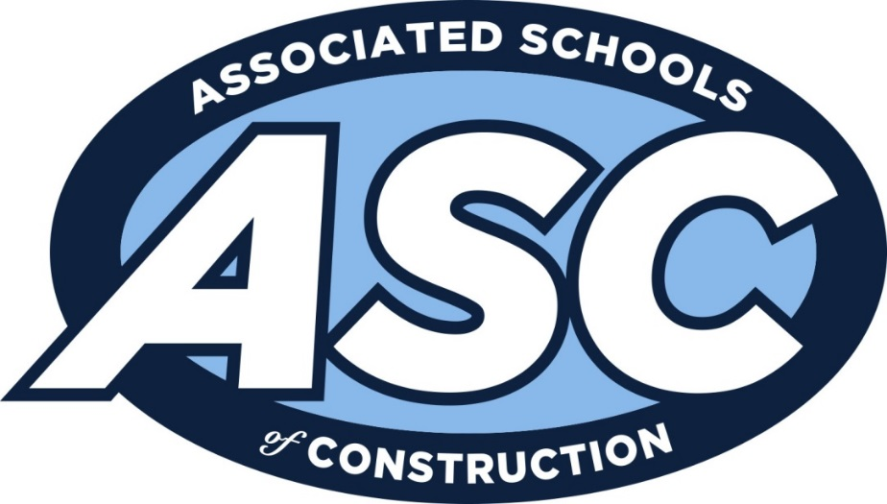

**Region 5 Student Competition- Feb. 18-20, 2017**

**Crowne Plaza – Dallas, TX (2/19-20)**

**Intent to Compete**

|  |  |
| --- | --- |
| Institution Name |  |
| Division: Commercial; Design Build; International Design Build; Heavy Highway |  |
| Coach |  |
| Coach Email |  |
| Coach Cell Phone |  |
| Complete below  (If known) |  |
| Team Member 1 |  |
| Team Member 2 |  |
| Team Member 3 |  |
| Team Member 4 |  |
| Team Member 5 |  |
| Team Member 6 |  |

All Red Fields Required

Invoice for $100 for each ASC Member School Team and $350 for Non-ASC Member School Team will be emailed to the listed Coach

Please return to heather.yates@okstate.edu no later than Wednesday, November 30, 2016